1: Setting up a Workflow

Workflow regulates the movement of tasks in projects.

Workflow can be changed according to the ongoing project’s processes.

To get access to the Workflow's settings, you need to log in as a Jira Administrator and click on Project Settings (in the project’s window in which you're going to change the Workflow).

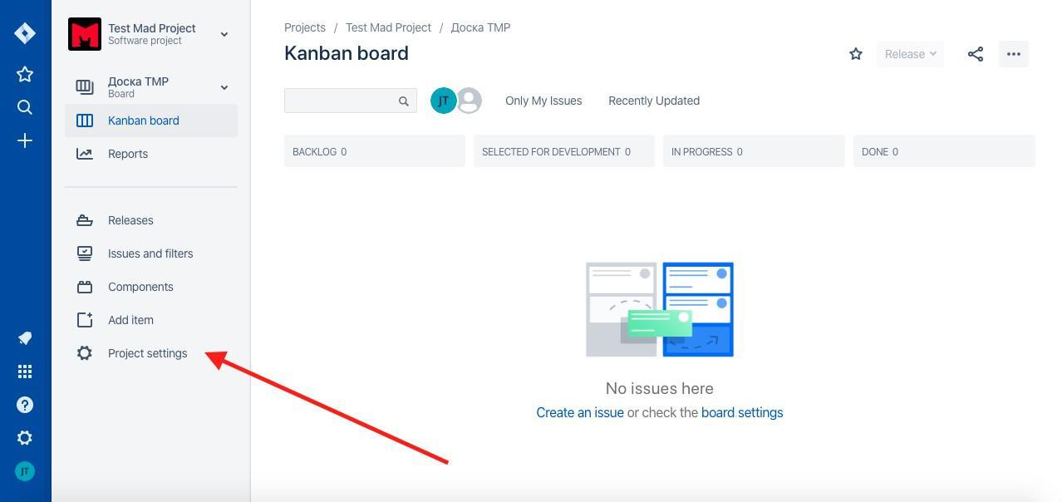

Next step: click on Workflows

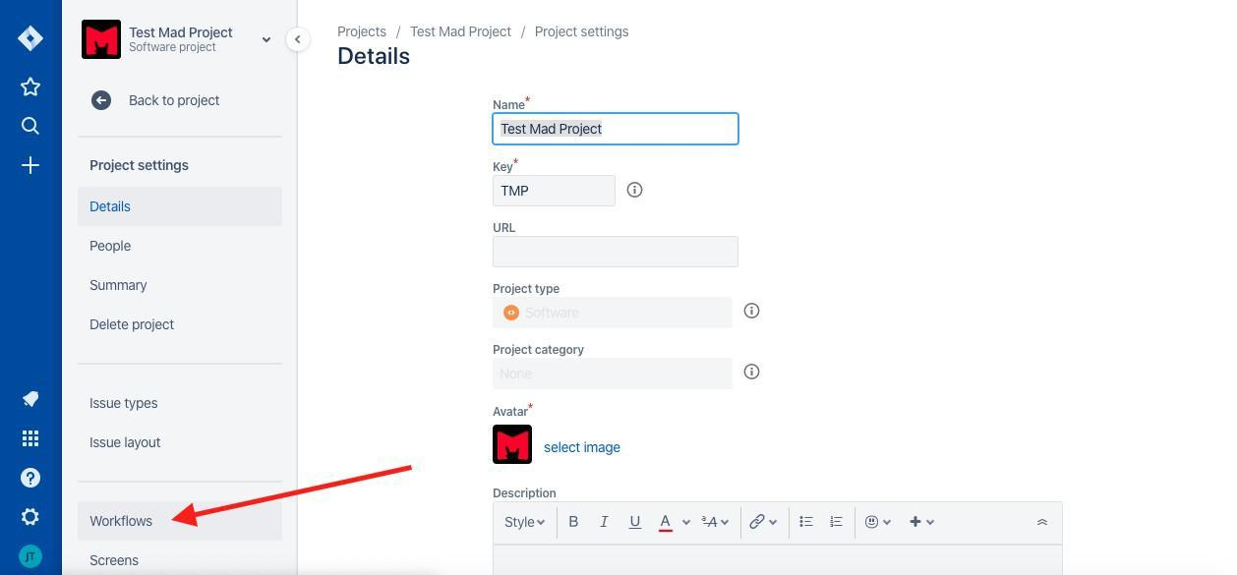

You’ll see a window with the current workflow of our project. There are 4 available actions:

1. Add a new workflow (add one of the classic workflows from Jira’s schemes or add another one from the marketplace).
2. Change Workflow’s scheme (If you have more than one preset Workflow schemes in your base).
3. View the current workflow as a text or diagram.
4. Edit current workflow.

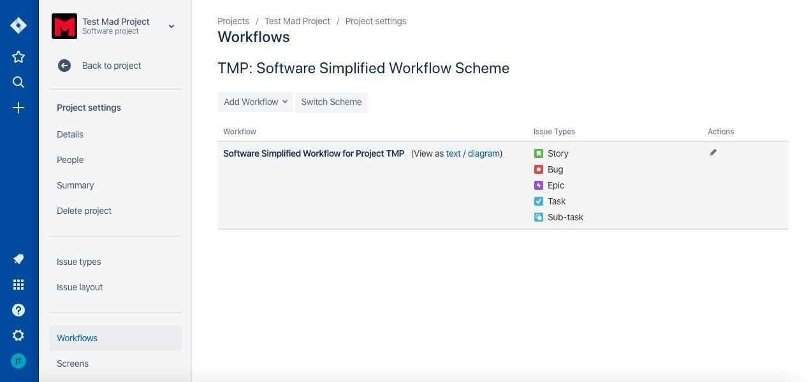

Let’s move on to the editing. Press on the pencil icon. Jira will send you to the Workflow’s edit page.

On this page we can see the following:

1. Workflow’s activation buttons (Publish changes; delete changes; View original).

2. Workflow’s name editing field.

3. A button that can show how many projects are operating using the scheme.

4.Switch the scheme’s form (diagram; text).

5.Workflow’s export button.

6. A field for directly configuring workflow elements.

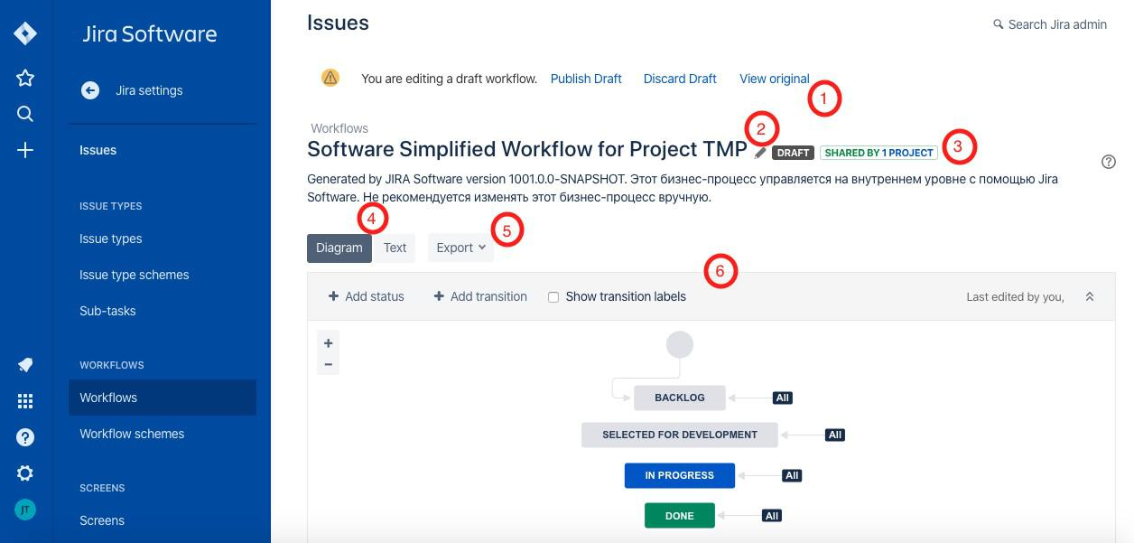

To change Workflow under the needs of a specific project, we recommend you to familiarize with Jira Atlassian’s oﬃcial documentations:

* Working with workflows - <https://confluence.atlassian.com/adminjiracloud/working-with-workflows-776636540.html>
* Advanced workflow configuration - [https://confluence.atlassian.com/adminjiracloud/advanced-workflow-](https://confluence.atlassian.com/adminjiracloud/advanced-workflow-configuration-776636620.html)configuration776636620.html